

THE GROUP INTERPERSONAL RELATIONSHIPS

THE GROUP INTERPERSONAL RELATIONSHIPS

In groups of 3 or 4, name two key persons in our group? How would you describe
their relationship to others in our small group?

Introduction.

Every person who comes to our small group wants to know how they will fit into the group. If we want to know how our small group interacts with each other, the sociogram is the key to the group dynamics.

I. DEFINITION OF A SOCIOGRAM.

A sociogram is a graphic representation of social links that a person has. It is a
graph drawing that plots the structure of interpersonal relations in a group situation.

II. SYMBOLS OF A SOCIOGRAM.

□ ○ 1. Make a circle (female) and square for males

KT RT 2. Put the initials of each person in a circle or square in our small group.

3. Draw the following lines

● Draw a solid line to indicate a strong relationship

● Draw a two solid line to indicate very strong relationship

● a series of dotted line to indicate a weak, but growing relationship

● An arrow to reflect the stronger relationship

● A continuous wavy line to indicate clash, tension

● No line if there is no relationship between one person and another

] ● A dotted circle line around the person to show alienation from the group
in some way

)) ● A less series of solid circle line to show amount of interaction with the group

))))) ● Series of solid circle lines to show the amount of interaction while in the group

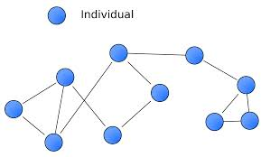

ILLUSTRATION OF A SOCIOGRAM

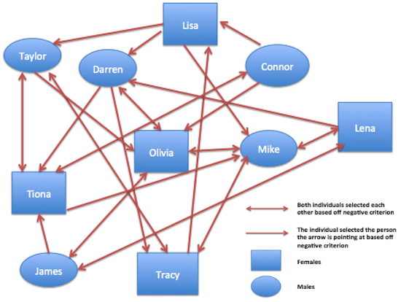

III. INSTRUCTIONS IN DIAGRAM OUR SMALL GROUP.

- Noting the following characteristics of members in our small group

● Who dominates the discussion?

● Who takes the most initiative in our discussions?

● Who takes initiative in unstructured times?

● Who takes the least initiative, quietest in our discussion?

● Who is most open in sharing in our discussion?

● Who sits next to whom consistently?

● Who do the members gravitate toward the most to in our group?

● Who are the thinkers in our small group?

● Who is in conflict with whom?

● Where do you fit into the group and whom do you connect to?

IV. DRAW A SOCIOGRAM OF OUR SMALL GROUP.
Use descriptive words for each person in the group.

COMPOSITION OF OUR SMALL GROUP

Leader (Facilitator)

Oversee (Observer)

Apprentice Recruiter

Seeker

Baby Sitter

Open Chair

Hospitality Person

Growing Disciple

Special
Need Person

Questions:

- How many members are in each group?

- What resources are needed to meet this small groups?

VI. OBSERVATIONS OF OUR SMALL GROUP.

- How is our small group connected together? Who are the key persons?

- Looking at the relationships, which persons are growing spiritually? Why?

- Looking at the relationships, which persons are withdrawn and or not growing spiritually? What can be done to help them grow or to engage them?

- Who are the caregivers of our small group?

- Which members are inviting new people to our small group?

- Who are the organizers of our small group?

- Who has dropped out of our group and why?

- If the group was to birth a new group, where is the natural division? Why>

CONCLUSION:

We are all BRANCHES connected to someone, but the one person we must
all be connected to is JESUS CHRIST, THE VINE (John 15:1-8).

